Lisa Ramey: Former The Voice star announces new EP Foretaste and surprise single ‘Better Than That’

In the years since she became a national figure after appearing as a finalist on The Voice, Lisa Ramey has been cooking an excellent, unique brand of R&B-soul, which harkens back to the golden era of the late ‘90s and early ‘00s. In her prime, Lisa is set to reintroduce herself to the world with her brand-new EP, Foretaste.

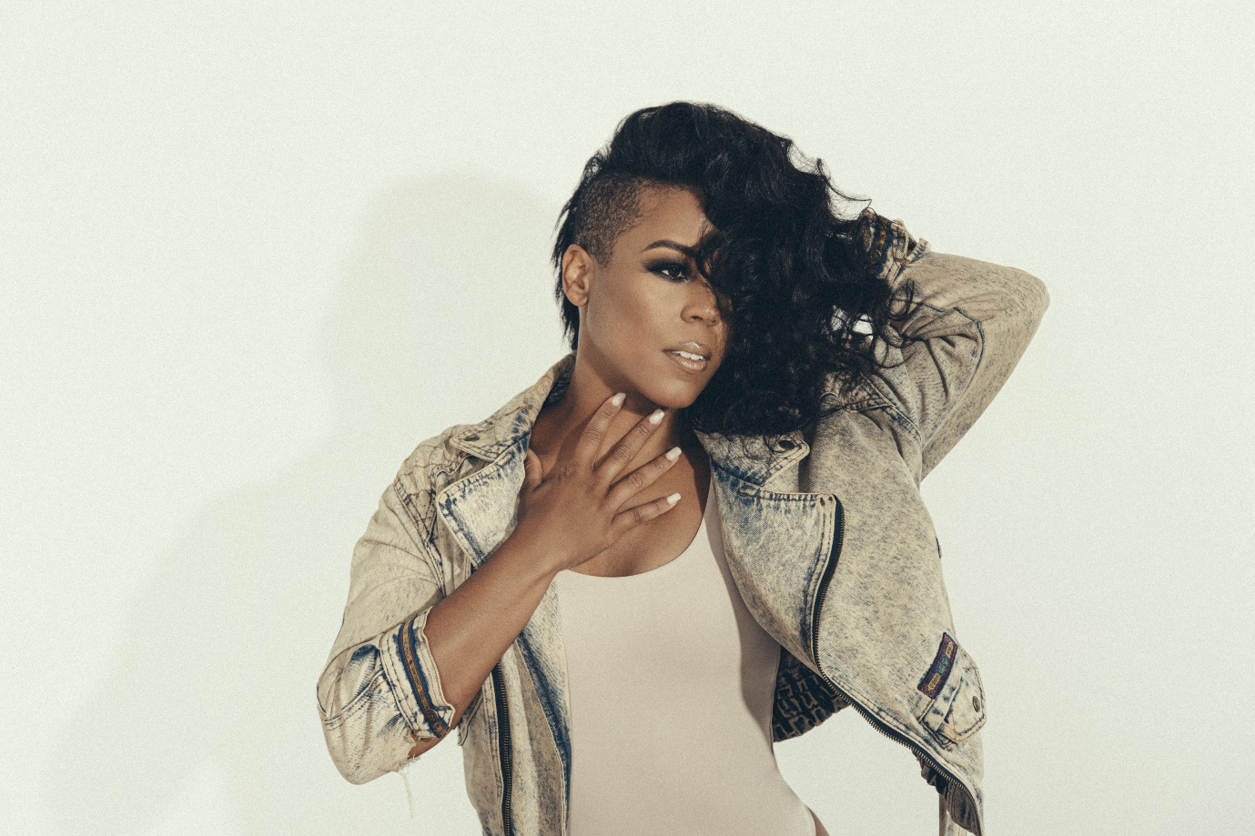
Photographer credit: Antonio T Harris
Stylist: Harriet Fitzpatrick

Lisa Ramey has announced that she’ll release her latest EP, Foretaste, on March 8 and a new single titled ‘Better Than That.’

Hailing from St Louis, Lisa Ramey has had an exciting and varied career in the music industry. She spent her early life inspired by soul artists, which led her to embrace being a performer. She fronted the funk-soul band Sugarbad throughout the early 2010s, building a reputation as a vocalist - and even gaining comparisons to Sharon Jones and Amy Winehouse.

The next chapter of Lisa’s career saw her feature as a soul singer for Cirque du Soleil’s KOOZA. In this role, Lisa toured worldwide and sharpened her performing abilities, even as she had to meet the physical and vocal demands of these live shows.

Following her time with Cirque Du Soleil, Lisa spent several more years building herself up as a singer - even performing the National Anthem at Madison Square Garden in 2016 - before her big watershed moment occurred after she appeared on The Voice US.

Lisa Ramey took part in Season 16 of the show and became one of the competition’s enduring highlights. Joining up with Team Legend, she was noted for her soul-stirring covers of songs like Kings of Leon’s ‘Sex On Fire,’ Stevie Nick’s ‘Edge of Seventeen, and The Band’s ‘The Weight.’

Lisa’s story took yet another turn in 2020. At the onset of COVID lockdowns, the artist plowed ahead with the release of her acclaimed debut album, Surrender. It was a soaring, soulful body of work, and despite the uncertainty of that period of history, Lisa was determined to use her music to connect with people and bring joy. She hosted live gigs regularly throughout this year, which not only helped her album become a surprise success story but also became one of the faithful musical beacons of light during this dark period.

There have been several other releases since this time, including Lisa’s 2022 album Broken Smile and several excellent single releases throughout 2023.

But this new year will be a decidedly big one for the artist. Lisa’s previous single, ‘Hopeless,’ came out in 2024 - and showed fans how brilliant she could be as an honest, commanding soul singer.

Photographer credit: Antonio T Harris
Stylist: Harriet Fitzpatrick

‘Better Than That’ is equally good. Its gentle piano riff, cascading, anthemic drums, and Lisa’s heart-achingly strong voice define the song. As in several of her previous songs, she addresses failed relationships, the mess they leave in their wake, and the strength that can be found in them.

‘Better Than That’ comes from Lisa’s new EP, Foretaste, out on March 8.

